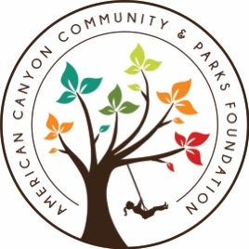
ACCPF After School Class Registration

First Name: |  | Last Name:
Child 1 Name: |  | Child 2 Name:
Email: |  | Email 2:
Day Phone: |  | Evening Phone:
Street Address: |  | City:
Check if Returning to Boys & Girls Club: |  | - Yes
Name of person picking up child:
Phone number of authorized person:
Name of additional person picking up child:
Phone number additional person picking up child:
Teacher Name: |  | Grade: | Classroom Number:
Allergies or Concerns:
Waiver Statement:
Waiver of Liability: I, the undersigned, in consideration of participation in the program(s) listed above, agree to indemnify and hold harmless, and release, waive and discharge BrickSpace, the American Canyon Community and Parks Foundation, and its employees from and against any and all liability for injury or property damaged which may be suffered by the above named participant(s) rising out of, in any way connected with participation in the program(s), including injuries due to the active or passive negligence of BrickSpace, the American Canyon Community and Parks Foundation and its employees.
This is not a program of Donaldson Way Elementary School, Napa Junction Elementary School, Canyon Oaks Elementary School, and NVUSD, the American Canyon Community and Parks Foundation and Mr. Scott Thomason and it’s partners accepts no liability or responsibility for this program.

Signature: | Date:

Photo Release: From time to time we share images or videos of our events on social media and our website. I hereby grant permission to ACCPF to use photographs and/or video of my child taken during after school classes in publications, news releases, online, and in other communications related to the mission of ACCPF.

Por la presente, doy permiso a ACCPF para usar fotografías y / o videos de mi hijo tomados durante clases despues de la escuela en publicaciones, comunicados de prensa, en línea y en otras comunicaciones relacionadas con la misión de ACCPF.

Signature: | Date:

